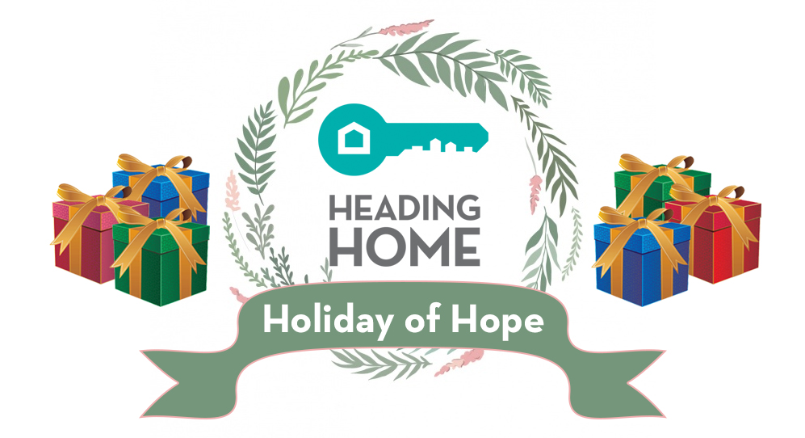

This year alone, Heading Home will serve nearly 1,000 family members through its housing programs for individuals experiencing homelessness. More than 80 families are expected to be clients of one of our programs this holiday season. We are honored with such great responsibility but we need your help to provide our families with some holiday cheer! We hope you will consider “gifting” one of our families. You will be provided with information about the families who need your help. This is a wonderful opportunity for families or for groups to do something meaningful TOGETHER this holiday season!

Please use this form to sign up to be matched to a family. If gifting one of our families is not the right fit for you, you can also provide us with any gifts for children of any age. This year, you can order preselected gifts on Amazon and have them shipped directly to us. For other items, please see our wishlist that is posted on our website, https://headinghome.org/holiday-of-hope-2019.

Any of these items may be dropped off at our downtown location: 215 3rd Street SW (corner of Silver and 3rd Street). We will issue a receipt for tax purposes.

Since 2004, Heading Home has served thousands of individuals who experience homelessness on the streets of Albuquerque. We provide supportive housing services to men, women, veterans, and families. Starting with this year, we will also be operating the Albuquerque Winter Shelter.

If you are interested in participating, please contact us by November 10, 2019. Please contact Dorothee Otero at 226-1700 Ext. 204 or at dorotheeo@headinghome.org.

HeadingHome.org
Gift a Family
Donor Name (Group or Individual): ___________________________________________________
Contact Name: ____________________________________________________________________
Address: ________________________________________________________________________
Phone #: ___________________email: ________________________________________________

Please match me with a family of no more than ______ (#) children. We do not expect you to gift the adult household members but you can honor them with groceries, toiletries, or a gift card, if you wish.

We will provide you with a list of the children by gender, age, and preferences. We will match families with sponsors during the third week of November. At that time, we will provide you with the children’s wish list. Because of privacy concerns, we do not allow delivery of gifts to the family’s home.

If you decide that you cannot sponsor a family at this time, please consider donating any of the items on the flyer.

For additional information, please contact Dorothee Otero at 344-2323 ext. 204. Return this form to our office by email: dorotheeo@headinghome.org, fax: 344-2088, or mail: P.O. Box 27636, Albuquerque, NM 87125, by no later than November 10, 2019.

Thank you so very much for your generosity.

